Project charter

* **Official project name**: Easy parking.
* **Project sponsor**: Ministry of transportation.
* **Project Manager**: Eng/Mohamed salah.
* **Purpose of the project**: help users to find a park place and decrease traffic jam.
* **Business case**:

The application will ........

* Help the user to find easy and quick parking space.
* Helps the user to find the nearest garage.
* Solve the Crowing streets congestion crisis.
* Reducing fines for parking in the wrong place.
* Be easy to use.
* **Key deliverables**:

This is the first application for parking on both android and ios.

* **Project milestones**:
* Requirements review: requirements specifications are complete, correct, approved and suitable. By 20/11/2021.
* Critical design review: Detailed designs fully implement the system architecture, are approved and are suitable for input into the development of code. By 5/12/2021.
* System test review: The software product has passed system testing and is suitable for input into acceptance testing. by 25/2/2022.
* Product operational: The software is in use in its target operational environment.by 25/4/2022.
* **Project resources**:
* Staff: 2 android developers, 1 IOS developer, 1 back end developer.
* Hardware: 4 laptop and a server.
* Software: we will use java and php.
* **Budget**:
* Budget allocated for this project is 150000$.
* **Constraints**:
* This project must be delivered on 23/4/2022.
* This project must be delivered within the specified budget.
* Any laptop or computer needed must bought from Lenovo.
* **High level risks**:
* The biggest problem of this project is the insufficient amount of money specified for its implementation. This is one of the biggest risks facing the work team and prevents the project from being completed efficiently or the inability to finish this project at all.
* One of the problems faced by the work team is a glitch in the program’s operating systems when making updates to the operating system to add or delete some features

Which leads to a great danger and may cause problems for users of the program.

* A user of the program may enter and register one of the empty spaces in a car park and then does not go to the place designated for him, which leads to the reservation of one of the places on the servers of the program without there being anyone, which causes some problems for some other users who are nearby and need places empty for their car.
* When the server of the program malfunctions, this leads to many problems for the users of the program. This failure may occur due to technical problems, or because of one of the errors of the work team, or because of an error outside our control, so we must try to avoid these errors.
* One of the problems or risks that the program does not face may be the user’s failure to deal with the program or record its data or its current location to show the empty places and this is one of the risks associated with using the program.

# The Project Scope

# 

# **Product Scope Description:**

* This project will mostly target the elderly and people with special needs, but it will also be available to all people to facilitate their working life.
* This project will start with local country then spreading worldwide.

# **Product Acceptance Criteria:**

* Installation of the developed system at the actual location.
* Creating the right remote control (application) to control devices easily.

# **Project Deliverables:**

* Application.
* Project plan, reports, documents and resources which return to the company.

# **Project Exclusions:**

* One of customers requirements that the app must work without using internet, but the sponsor and manager refuse this request as it need a lot of time and cost.

# **Project Constraints:**

* This project must be delivered within the specified budget.
* This project must be delivered on 23/4/2022
* Any laptops or computers needed must be bought from dell or apple companies.
* Rules of company and policies.

# **Project Assumption:**

* Availability of all required resources.
* The existence of the financier of the project and the availability of budget.
* This application can run only on The IOS and Android operating system.

Work Breakdown Structure

**1-Start of the Project**

* 1. Client meeting for asking requirements and budget
  2. Meeting with team members
  3. Client meeting for discussing risk and threats associated with the project
  4. Planning
  5. Assign team and studying the project

**2-Developing**

2.1 Buying compatible devices

2.2 Integrating them with each other

**3-DESIGN AND IMPLEMENTATION**

* 1. Design UX/UI for IOS and Android
  2. Design connection between mobiles and GPS
  3. building GPS connection
  4. Testing the complete design and casing

**4-Implementation**

* 1. Installation of devices
  2. Adjusting the system to the real world
  3. Final testing

**5-Training and Handling Over**

5.1Training client

* 1. Handling over of security information (keys/password)
  2. Describing polices
  3. Final report
  4. Closing of project

WPS dictionary

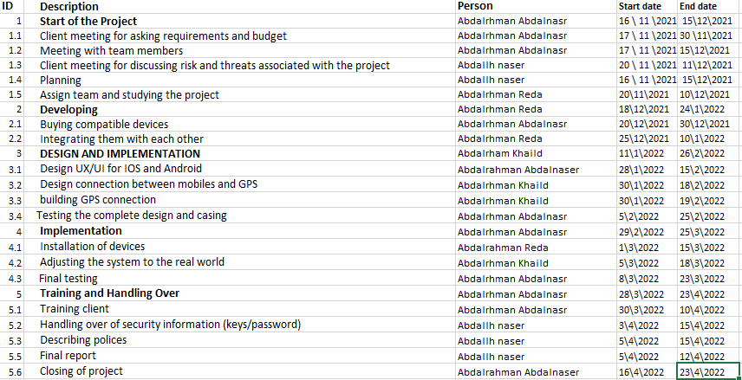

Responsibility Matrix

|  |  |  |  |  |
| --- | --- | --- | --- | --- |
| tasks | Abdo nasser | abdallah | Abdo Khaled | Abdo Reda |
| Client meeting for asking requirements | R |  | s |  |
| Meeting with team members. | R |  | s |  |
| Client meeting for discussing risks and threats associated with the project |  | R |  | S |
| Planning | S | R |  |  |
| Assign team and studying the project |  |  |  | R |
| Buying compatible devices | R |  |  | S |
| Integrating them with each other |  |  |  | R |
| Design UX/UI for IOS and Android | R | S |  | S |
| Design connection between mobiles and GPS |  |  |  | R |
| building GPS connection |  |  | R |  |
| Testing the complete design and casing | R |  |  |  |
| Installation of devices |  |  |  | R |
| Adjusting the system to the real world |  |  | R |  |
| Final testing | R | S |  |  |
| Training client |  | S | R |  |
| Handling over of security information (keys/password) | S | R |  | S |
| Describing polices |  | R |  |  |
| Final report |  | R |  |  |
| Closing of project | R |  |  |  |

Network

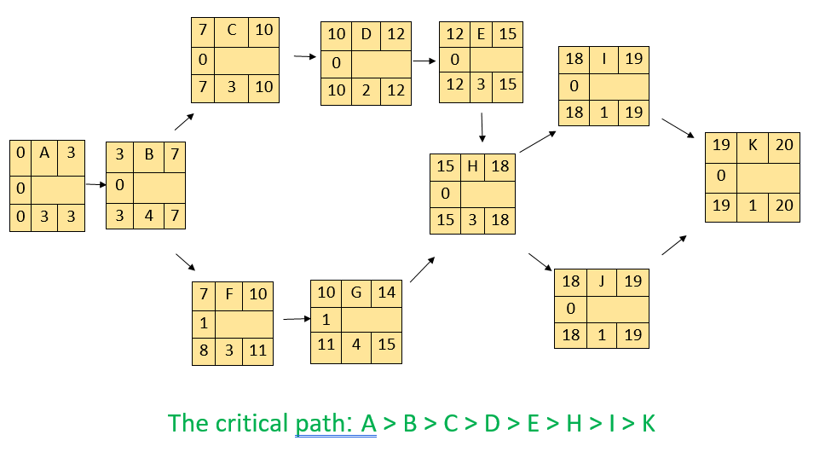

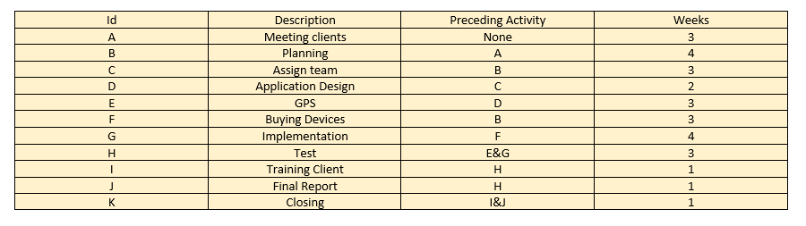

Recourse constrained

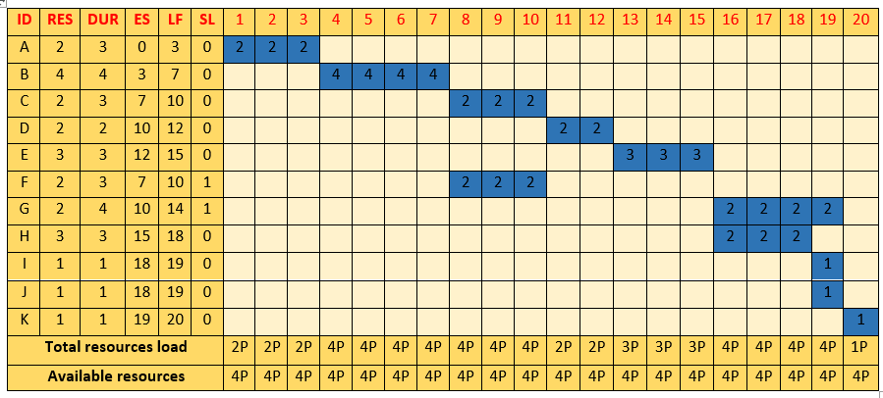

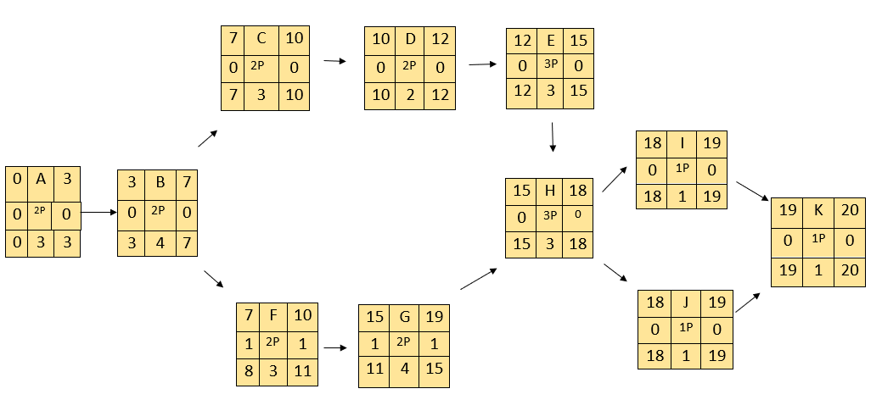

**Cost by week**

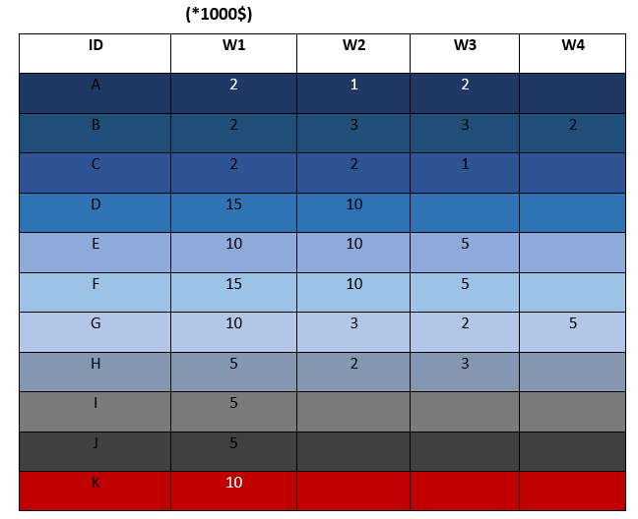

**Baseline Budget**

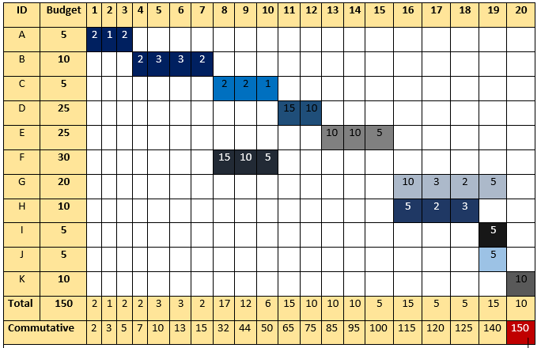

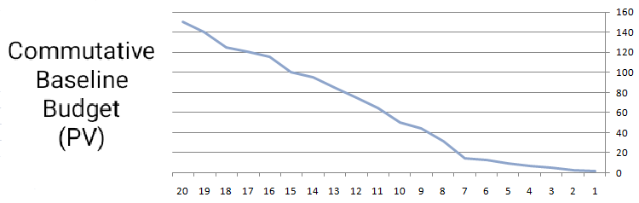

Risk Management & Monitoring

1. The biggest problem of this project is the insufficient amount of money specified for its implementation. This is one of the biggest risks facing the work team and prevents the project from being completed efficiently or the inability to finish this project at all.

* Risk level: high.
* (Solution) These risks can be reduced by paying attention to all project details and not wasting any of the resources or budget allocated to the project.

1. One of the problems faced by the work team is a glitch in the program’s operating systems when making updates to the operating system to add or delete some features Which leads to a great danger and may cause problems for users of the program.

* Risk level: medium.
* (solution) Choosing a team at the highest level is one of the most important basics of success in our project. This leads, for example, to the completion of the project in the required time and the ability to be satisfied with the budget and resources of the allocated project and not needing more, as well as the ability to fix any defect that occurs in the system due to a technical error or negligence One of the individuals, which leads to an increase in efficiency.

1. A user of the program may enter and register one of the empty spaces in a car park and then does not go to the place designated for him, which leads to the reservation of one of the places on the servers of the program without there being anyone, which causes some problems for some other users who are nearby and need places empty for their car.

* Risk level: low.
* (solution) The use of a team of programmers at the highest level and with competencies to be able to solve the problems of updates that occur to our program.

1. When the server of the program malfunctions, this leads to many problems for the users of the program. This failure may occur due to technical problems, or because of one of the errors of the work team, or because of an error outside our control, so we must try to avoid these errors.

* Risk level: low.
* Continuous updating of the program’s servers so that there is no glitch when reserving a place and not going to it, for example, setting a specific time if the customer does not go to his designated place, the data is deleted so that others can benefit from it.

1. One of the problems or risks that the program does not face may be the user’s failure to deal with the program or record its data or its current location to show the empty places and this is one of the risks associated with using the program.

* Risk level: low.
* Making the program’s interface easy to deal with the user so that he does not find it difficult as well as adding some features such as the ability to search by voice and keep the customer’s previous data in his profile so that he can access it easily.